localhost:4200

localhost:4200/home

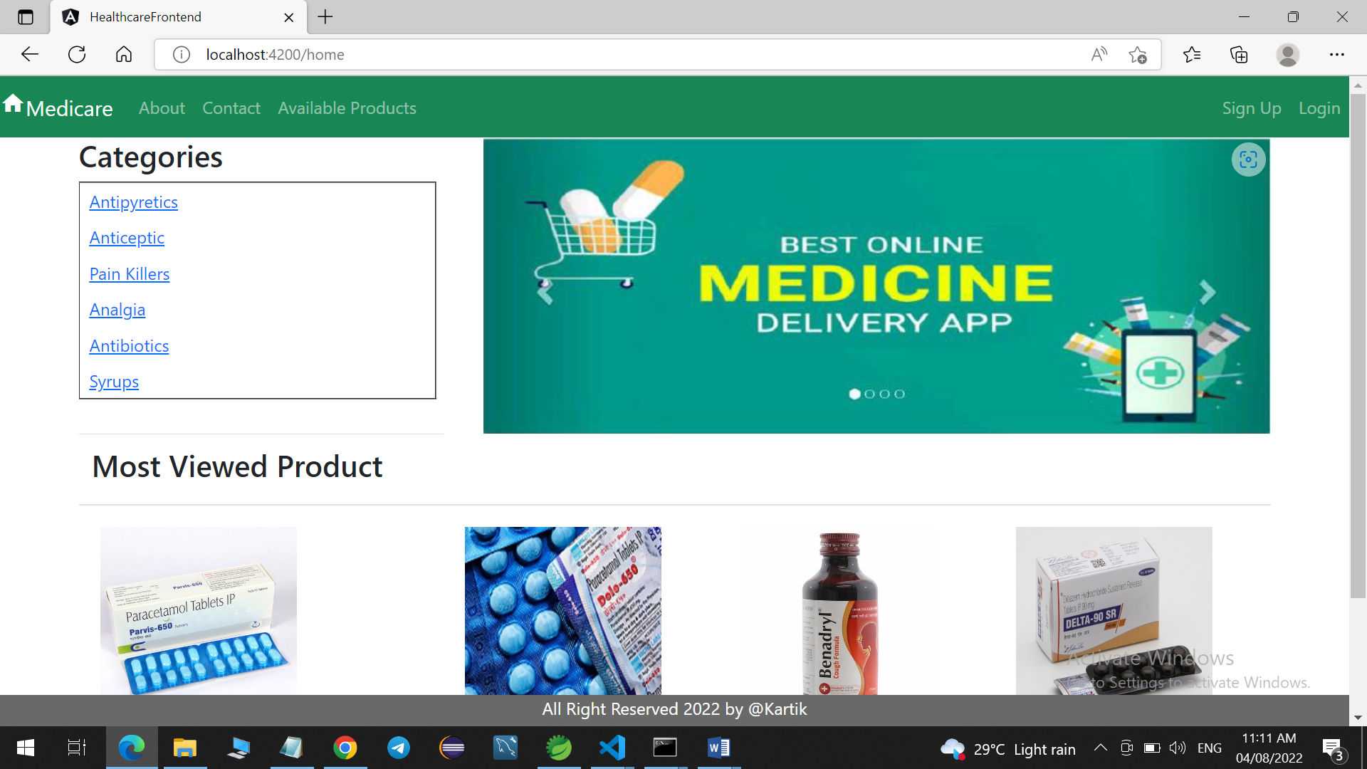

Sign-up page for users

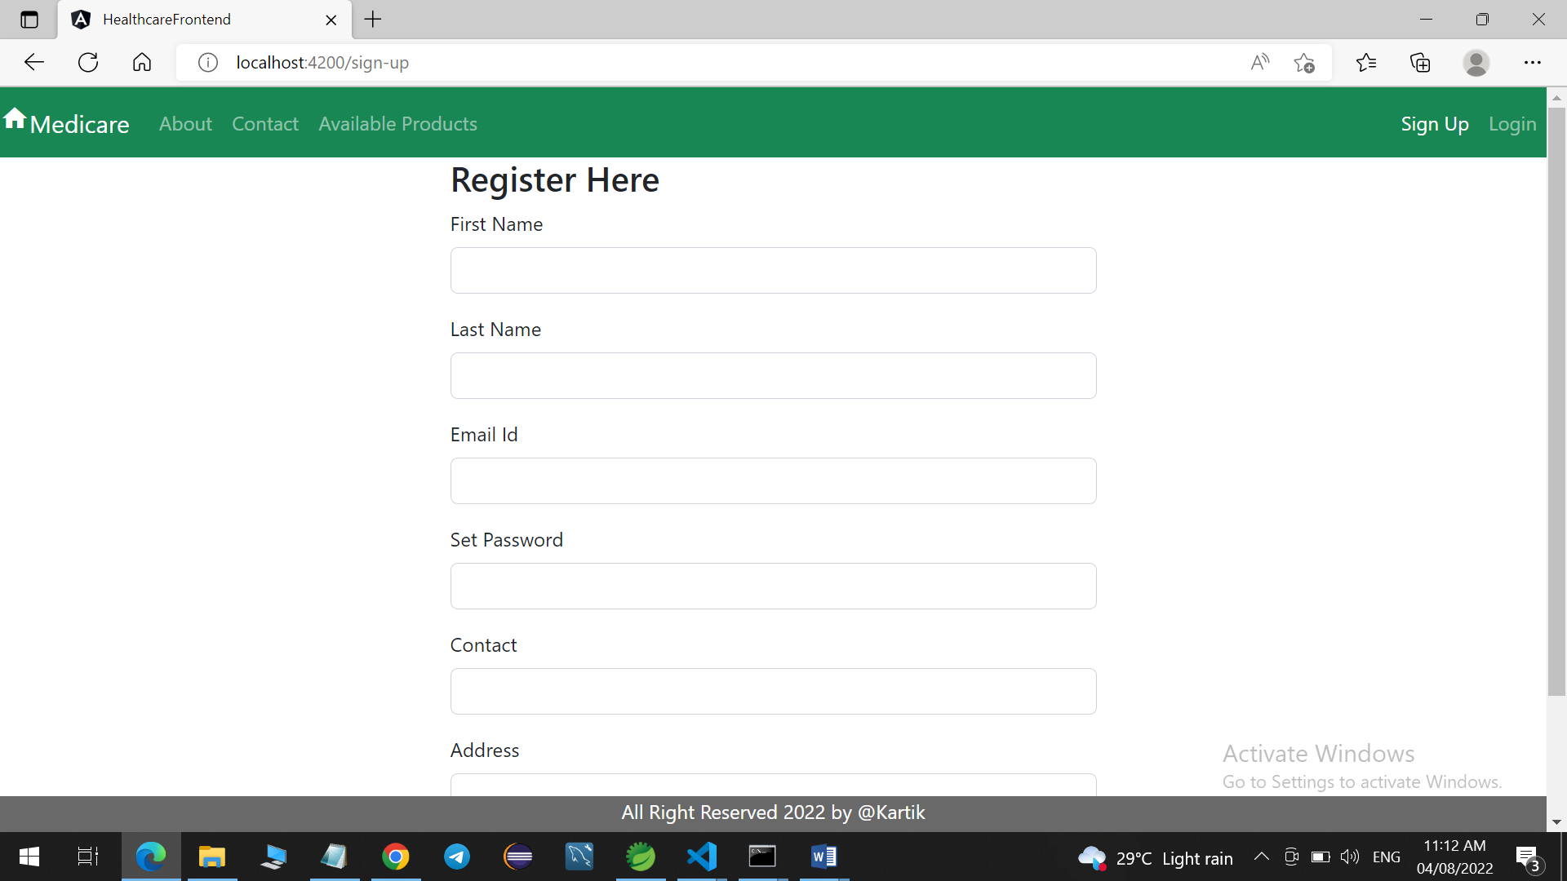

Login page for user and admin

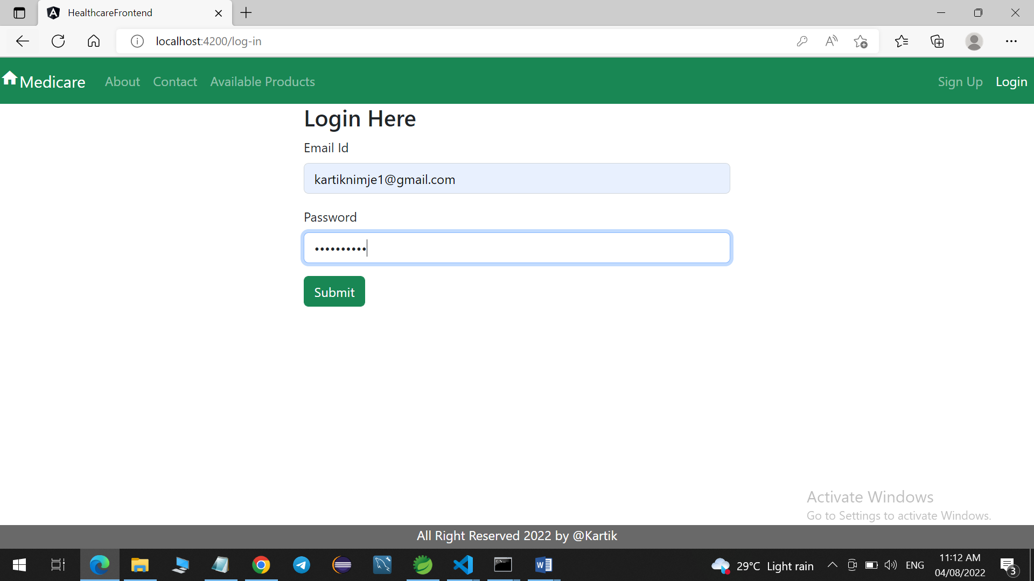

User and Admin can check available medicines

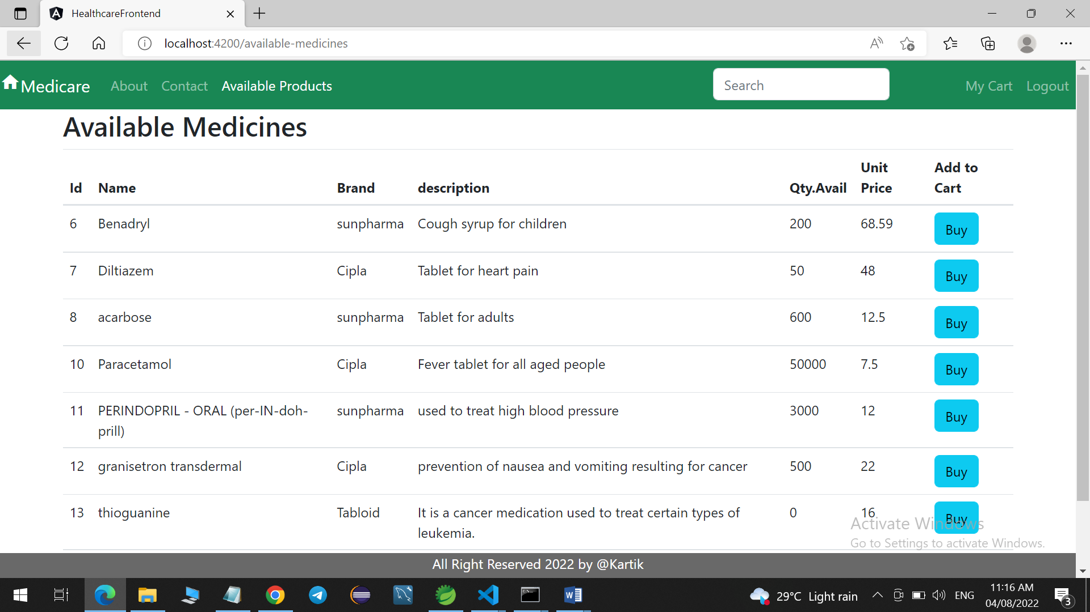

About us page

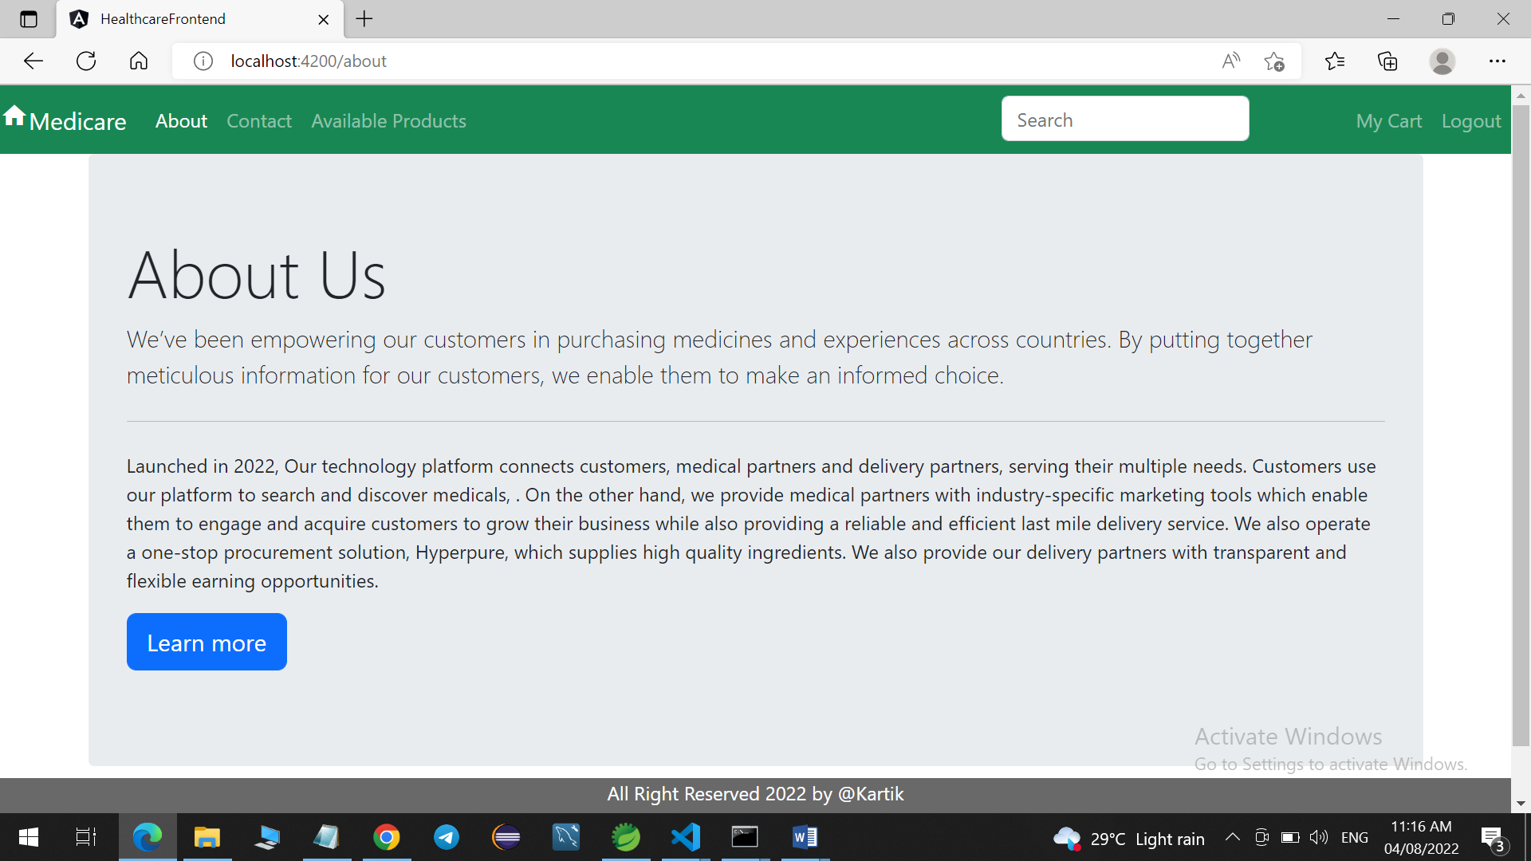

Contact us page

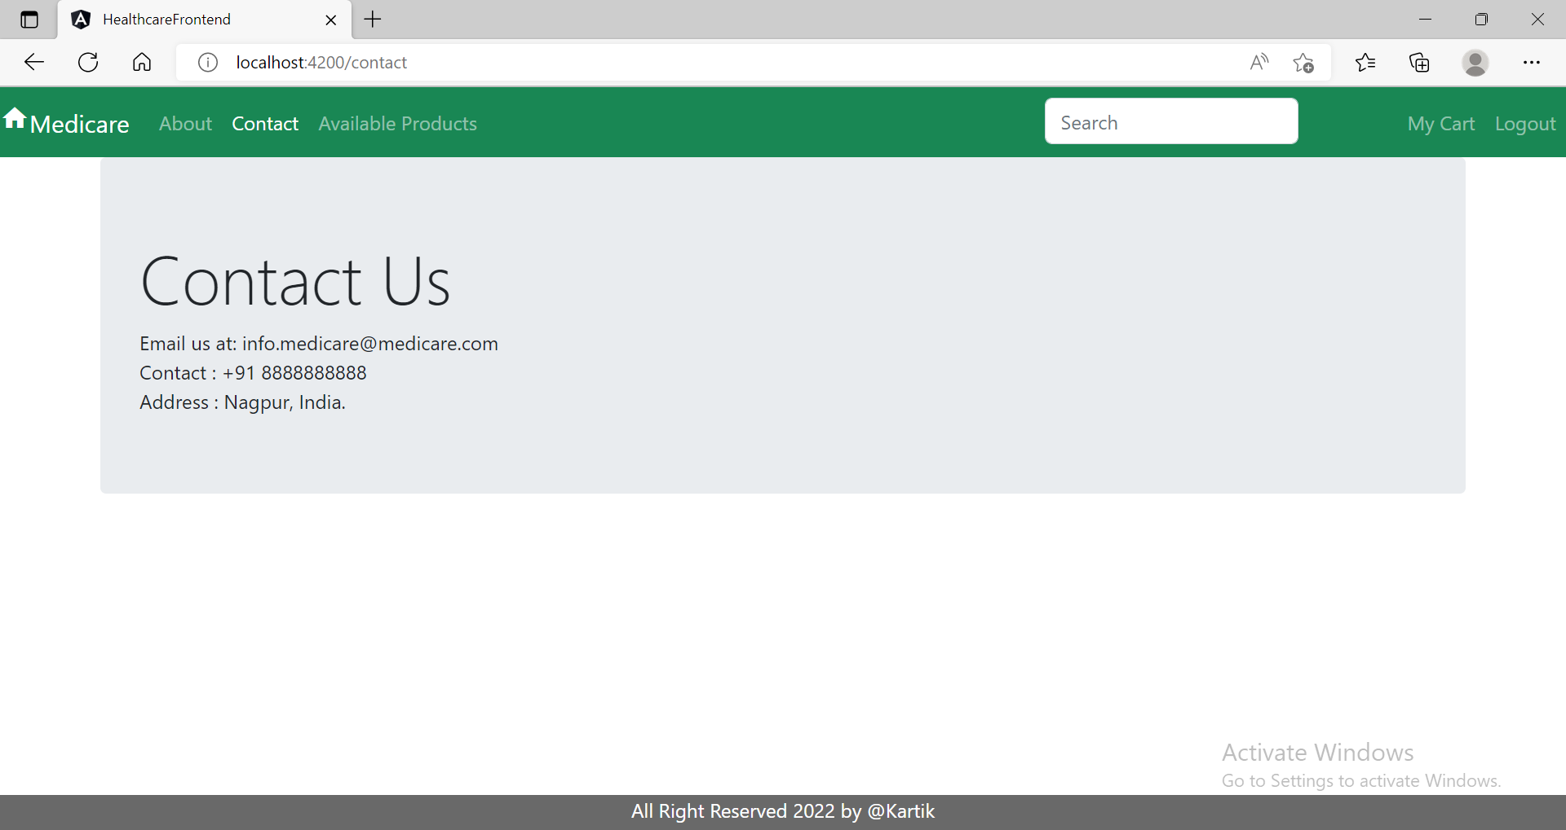

Shopping Cart (Quantity field can be edited, so the Subtotal will be changing accordingly)

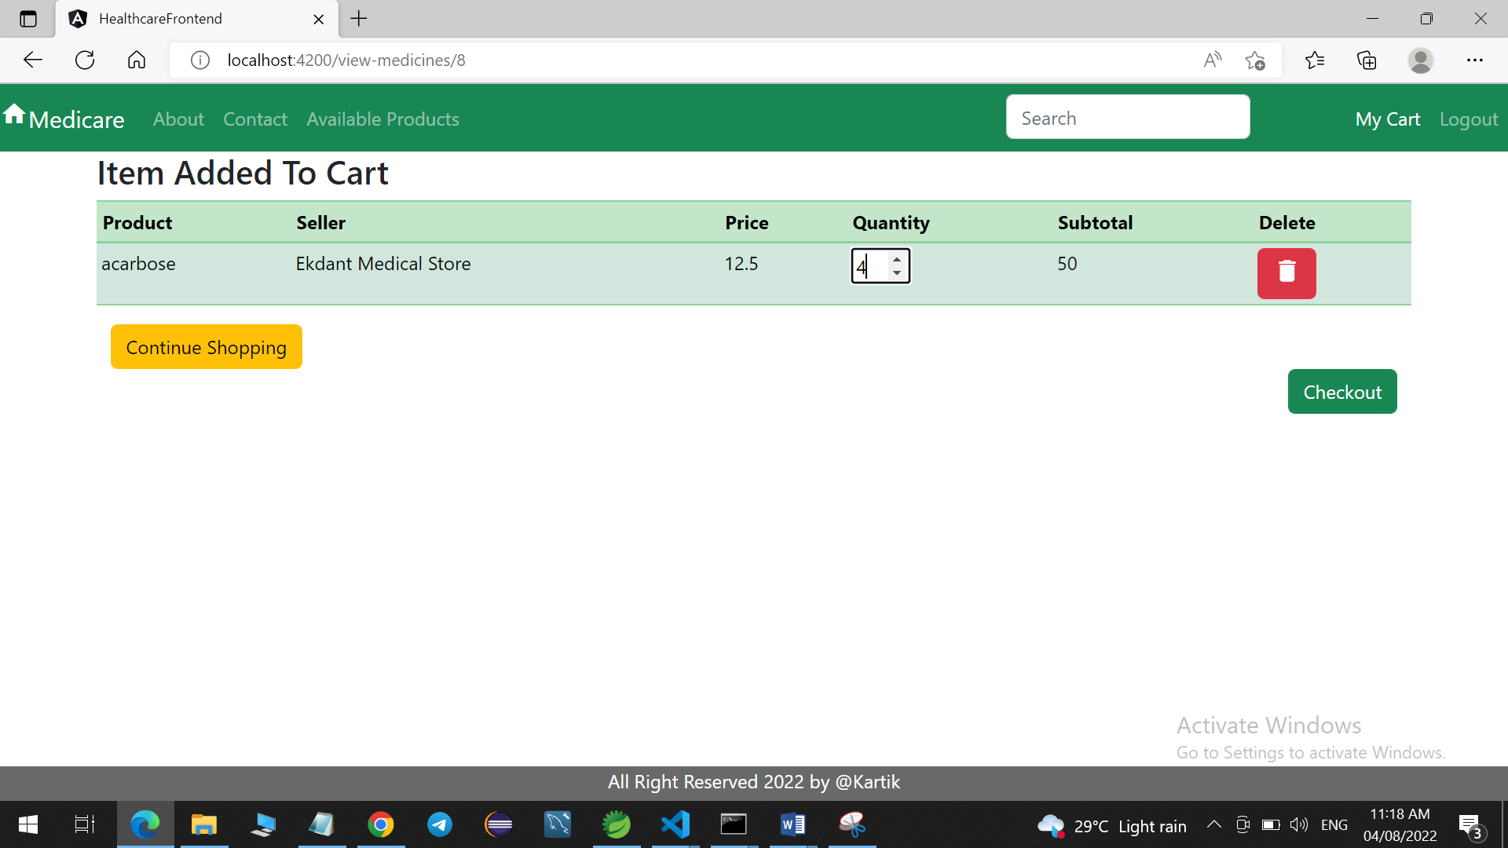

Home page after user log-in

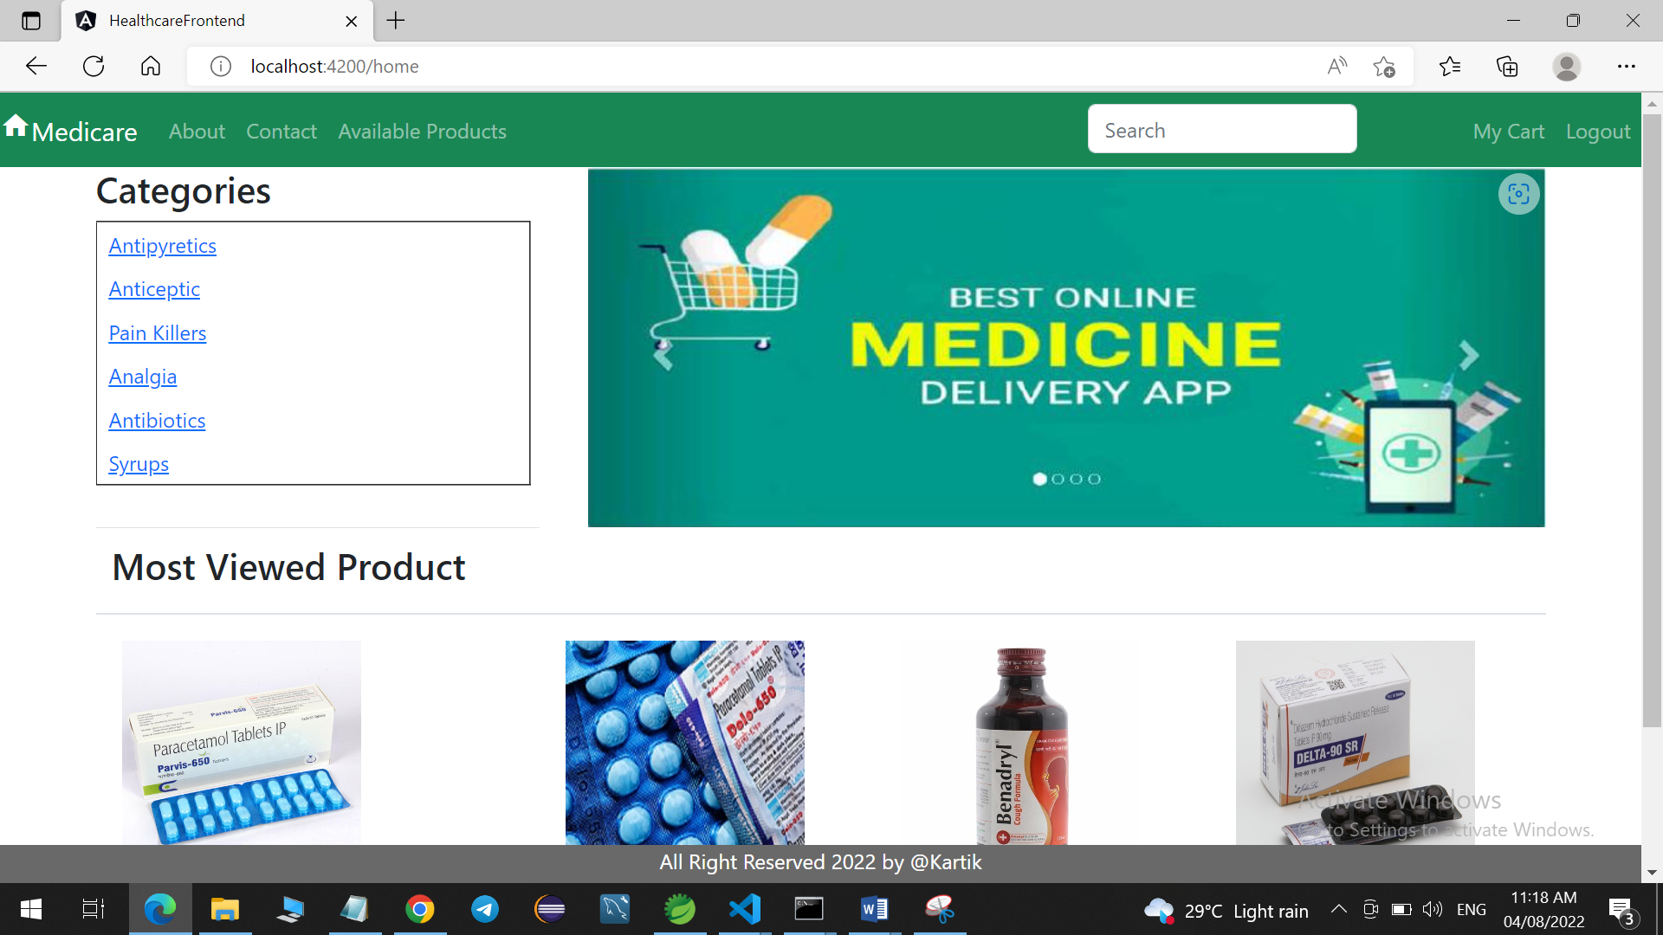

Admin Home Page

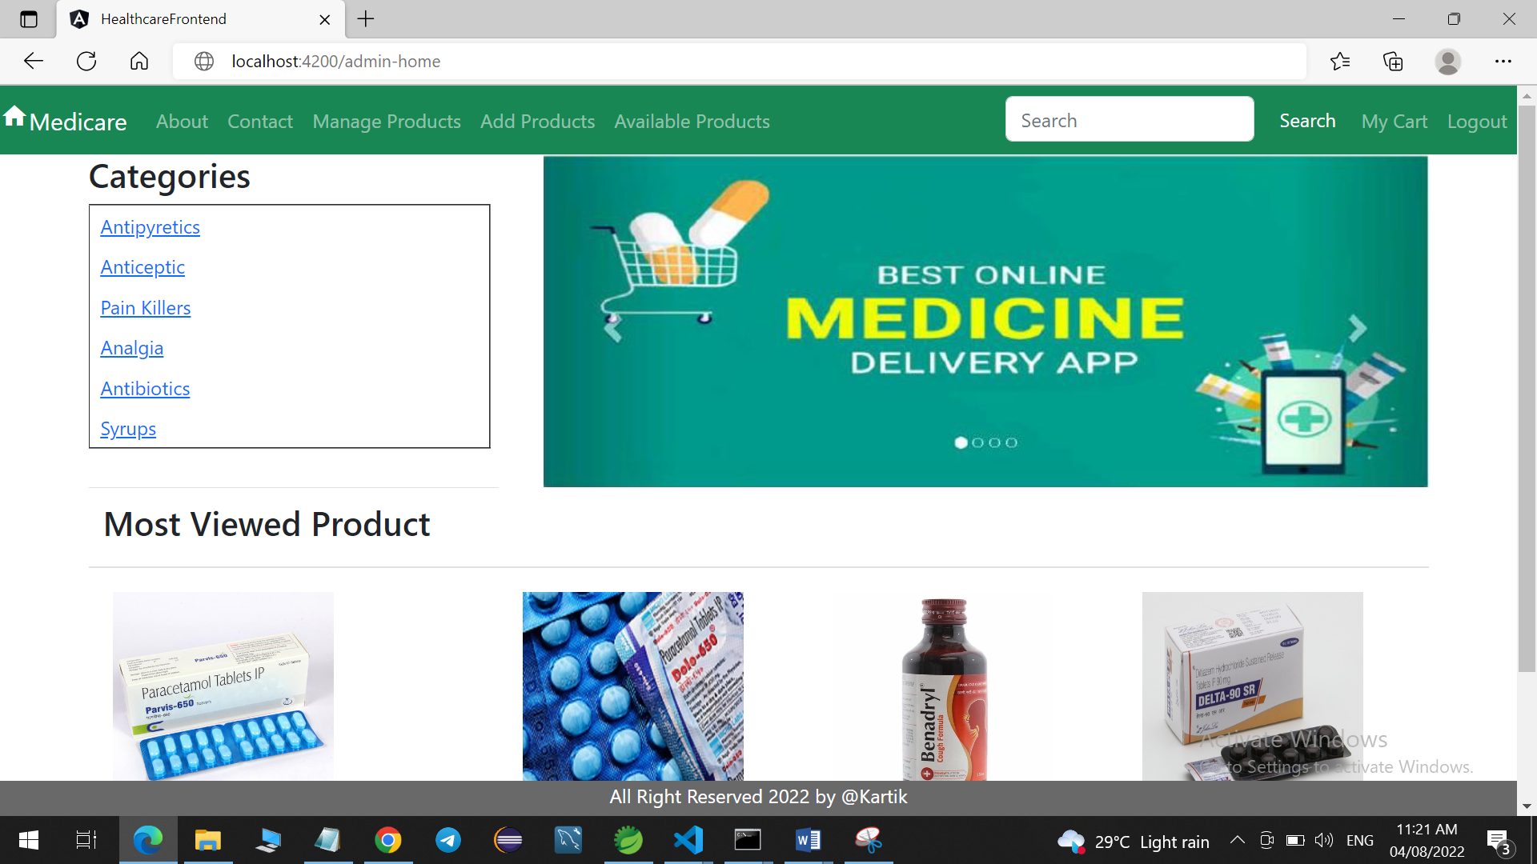

Admin can manage product by activate deactivate, edit and remove operation

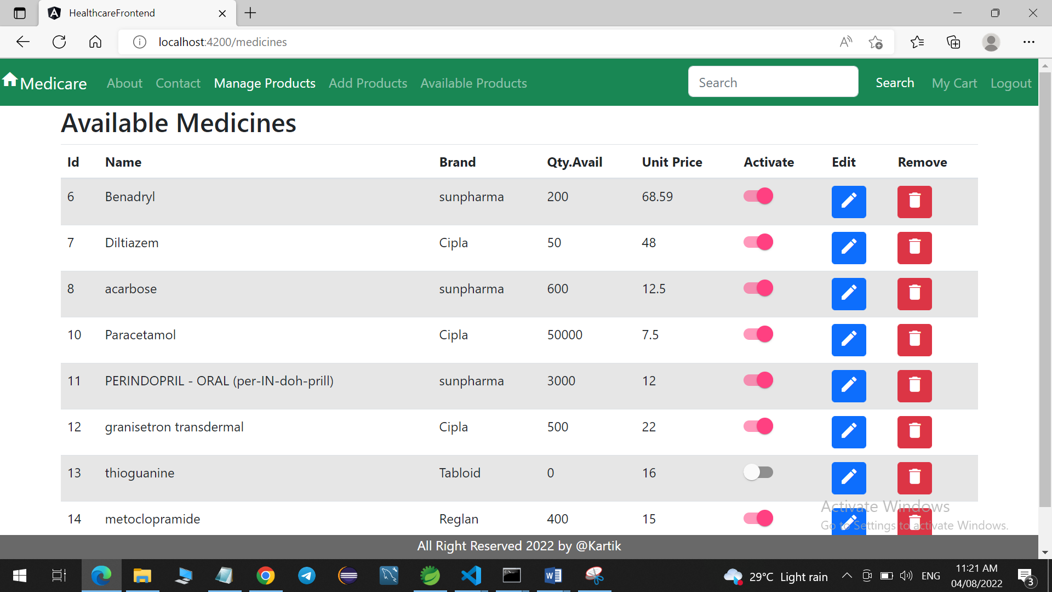

If admin click on edit icon, he/she can edit the information for that particular product. Information will be populate automatically over the form.

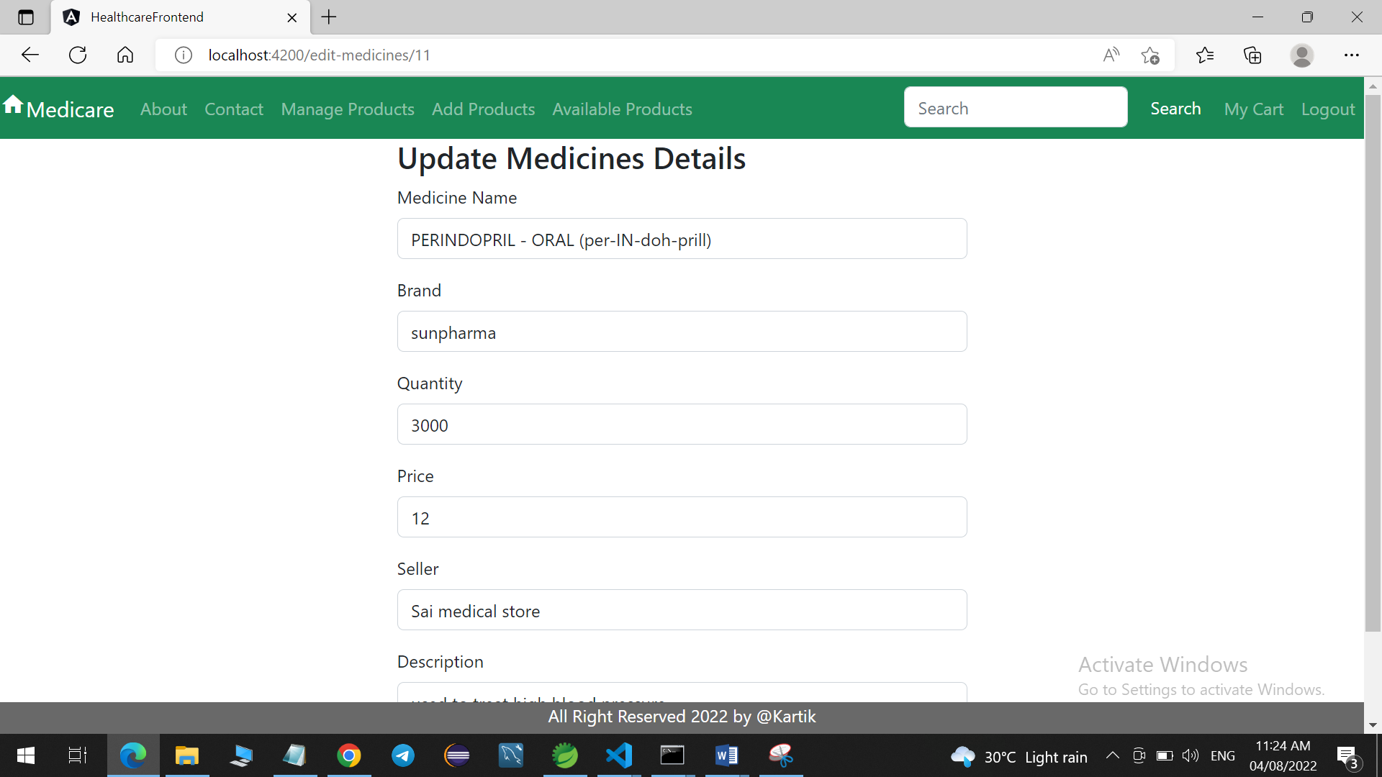

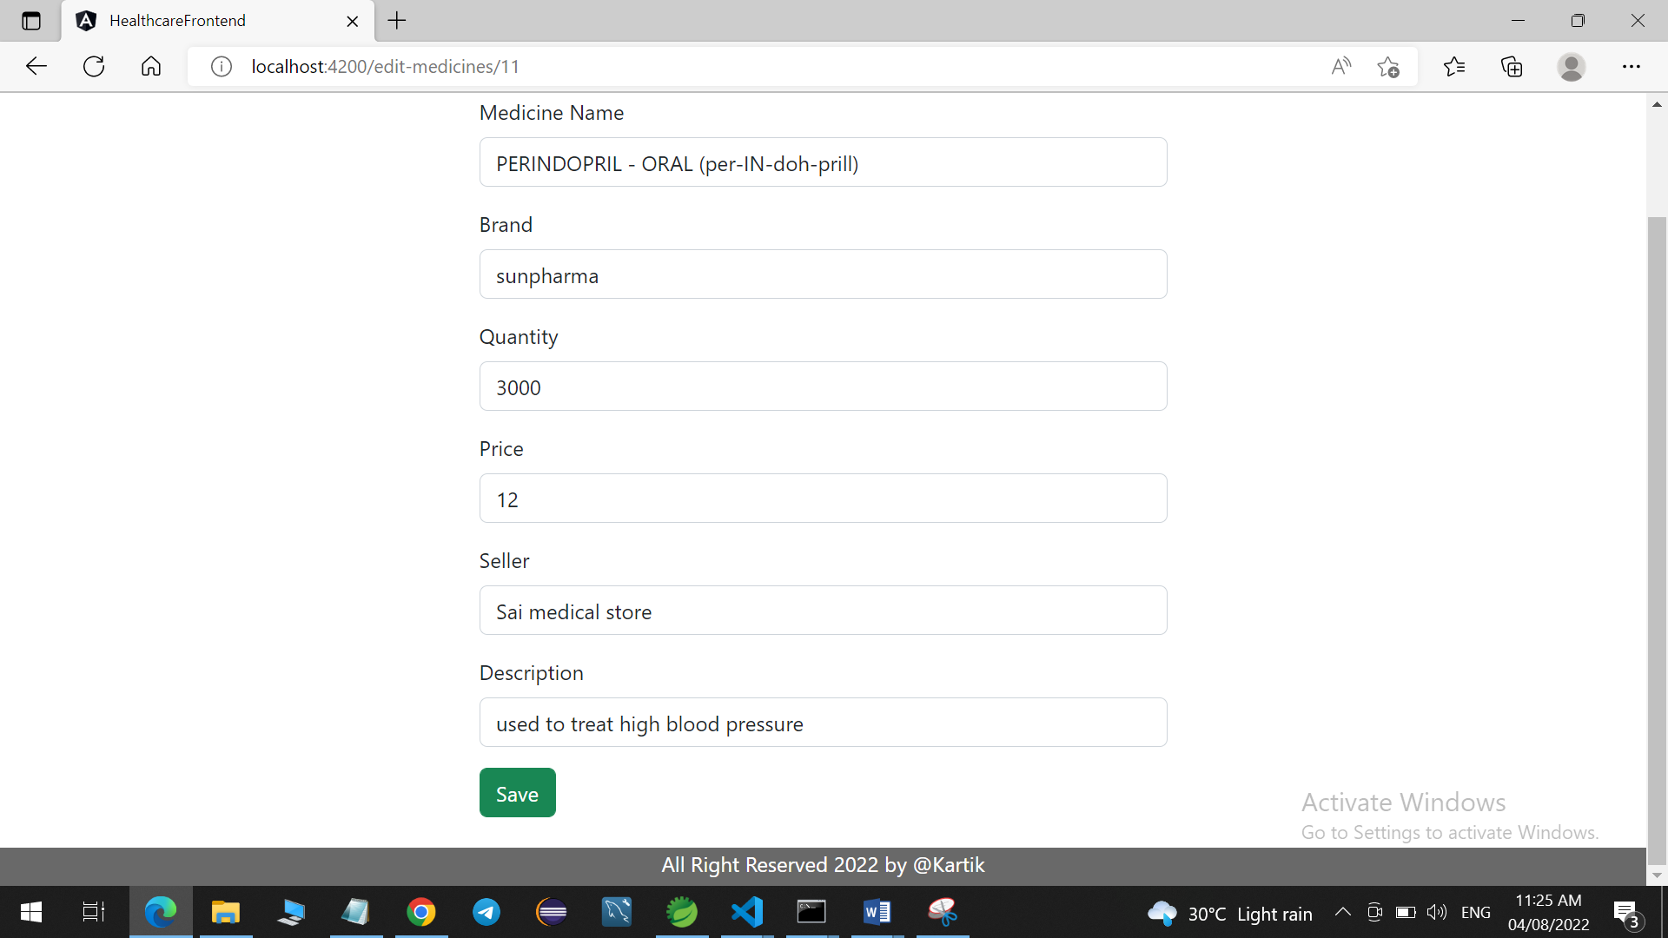

If admin click on delete icon for any medicine, it will get removed. (If e.g. admin click on delete icon for medicine having id is 11)

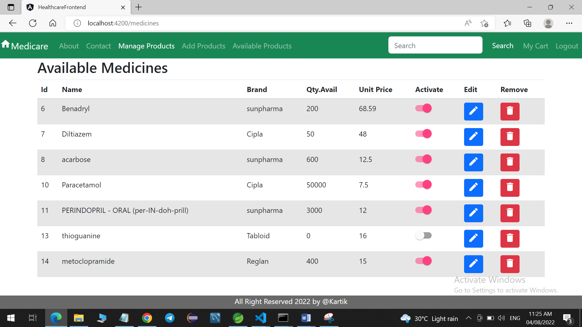

Admin can add new medicines from Add Products navigation bar link

